

**Veeam Backup for Office 365**

**Plugin Configuration Guide**

Contents

Supported Collection Types 2

Data Sources 2

Requirements 2

Network Ports 2

Veeam Backup O365 Configuration Checklist 2

User Configuration & Bocada Setup 2

Bocada Setup 3

Server Properties 3

Field Definitions 3

Reporting Notes 4

Technical Support 4

# Supported Collection Types

The plugin currently supports the following collection types from Veeam Backup for Microsoft Office 365 servers:

|  |  |  |
| --- | --- | --- |
| **Collection Type** | **Supported** | **Description** |
| Backup | ✓ | Collects transactional details about backup jobs. Example metrics include, start times, durations, bytes, files, errors etc. |
| Storage | ✓ | Collects point-in-time inventory information. Example metrics include, total recoverable gigabytes (storage), media volume count, media volume status, etc. |
| Policy |  | Collects and stores information on policy attributes, schedules, storage units, storage groups, storage lifecycle policies and clients. |

# Data Sources

The plugin relies on the following Veeam Backup O365 data sources:

* REST API

# Requirements

The Bocada Data Collection Server must be able to connect to the Veeam Backup O365 Server on the port(s) listed in the table below. It should be open for “Outbound” communication on Bocada DCS side and for “Inbound” on VeeamO365 side.

### **Network Ports**

|  |  |  |
| --- | --- | --- |
| **Service** | **Default Port** | **Note** |
| *­­HTTPS* | 4443 | REST API connection through HTTPS |

Note: the port is 4443[sic] not the default HTTPS port of 443.

# Veeam Backup O365 Configuration Checklist

While detailed steps are included below, this is an overview of the steps to configure Veeam Backup O365 collections on your Bocada Data Collection Server:

* Credentials for users with the required permissions have been obtained

### User Configuration & Bocada Setup

Bocada collects all data for which the supplied user credentials have access. Users must be configured in administrator data access. Enable RESTful API Service, as described in this Veeam document:

<https://helpcenter.veeam.com/docs/vbo365/guide/vbo_rest_api_settings.html?ver=40>

# Bocada Setup

### Server Properties

Backup Server Properties determine how the plugin will interface with the Veeam Backup O365 server and are managed through the Backup Servers view.

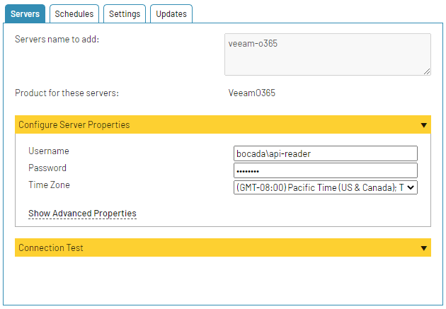

### Field Definitions

#### Username & Password

Enter the name and password for a Veeam Backup O365 user.

#### Time Zone

Select the time zone where Veeam Backup O365 server resides. This setting defines how job times will be shifted when reporting across different time zones.

# Reporting Notes

The following is how data points within Veeam are normalized and reported in Bocada.

|  |  |
| --- | --- |
| **Bocada Data** | **Veeam O365 Data** |
| Job Group | Organization |
| Policy | Job Name |
| Backup Client | Object primary (user name) |
| Target | Object detail (OneDrive, site, mailbox) |
| Media Type | Storage destination type (cloud, disk) |

Veeam Backup for Office365 only presents the byte counts of backups at a policy-level rather than at the end-user or resource level. This results in Bocada reporting a single parent job (client “n/a”) reporting the byte count of the group while the remaining jobs report other details like User and resource type (mailbox, OneDrive, site).

The example below shows all elements of a job and how they are reported under the same Bocada “Policy”, with the n/a parent client containing the byte count of the group.

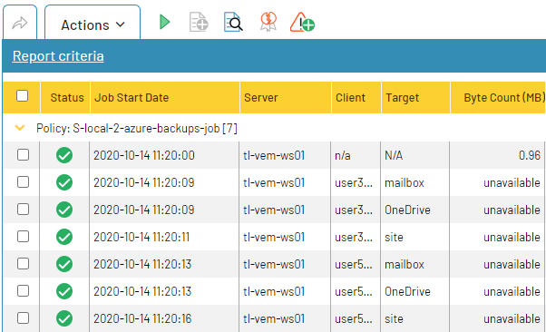

# 

# Technical Support

For technical support or a copy of our standard support agreement, please contact us.

**E-mail:** [support@bocada.com](mailto:support@bocada.com)

**Support Portal:** http: <https://bocada-support.force.com/s/>

**Phone:** +1-425-898-2400